1 - 1 – Function Families – Practice Set 1
Your goal is to rapidly form a picture in your mind of:
- The basic shape of each family
- Where they intersect
- How different members of the same family compare: eg. $x^{8}$ vs $x^{10}$

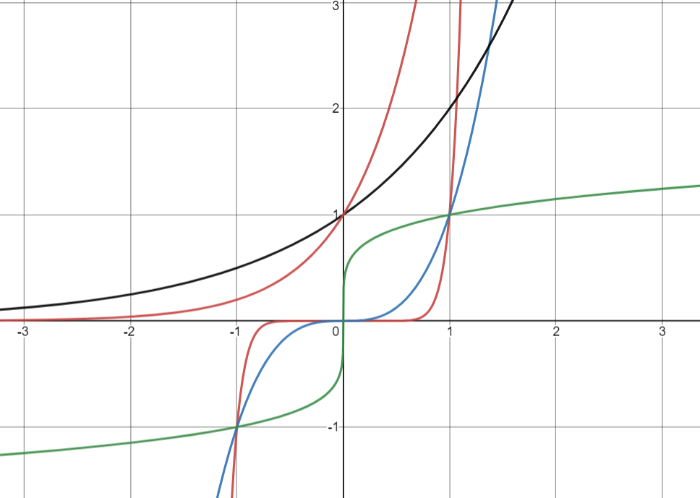
1. [P] Match each curve with its equation.
A
B
C
D
E
$y=\sqrt[5]{x}$ ____
$y=2^{x}$ ____
$y=5^{x}$ ____
$y=x^{3}$ ____
$y=x^{11}$ ____

2. [P/C] Sketch a graph of $y={\sqrt{2}}^{x}$. Label two sets of coordinate points you know on the graph.
3. [P/C] For each pair of functions, write all points where they overlap. Which function has larger y-values to the right of the overlapping point? to the left?
- $y=\sqrt[3]{x}$ $y=\sqrt[4]{x}$
- $y=2^{x}$ $y={\left(\frac{1}{2}\right)}^{x}$
- $y=\frac{1}{x}$ $y=\frac{1}{x^{2}}$
4. [P/C] The two questions below are phrased algebraically. Think about what they’re asking about the graphs of the equations. You can answer both questions just by translating the question to one about a graph and then looking at the graph in your mind.

a). If $f\left(x\right)={11}^{x}$ and $g\left(x\right)={\sqrt{2}}^{x}$, for what value(s) of k is $f\left(k\right)=g(k)$ ?
b). Say that $f\left(x\right)=5^{x}$ and $g\left(x\right)=b^{x}$ for some number b. If $f\left(-3\right)>g(-3)$ what do you know about b?

5. [P/C] Without a calculator, which is larger: $\sqrt[5]{\frac{1}{4}}$ or $\sqrt[7]{\frac{1}{4}}$ ?
(Think about the graphs of $y=\sqrt[5]{x}$ and $y=\sqrt[7]{x}$ at $x=\frac{1}{4}$ )
6. [P/C] Which of the following have a domain of all real numbers? Which of them have a range of all real numbers? You should answer these questions by looking at the shape of the graph in your mind.
$y=x^{100}$ $y=x^{51}$ $y=\sqrt[3]{x}$ $y=\sqrt[14]{x}$ $y=\frac{1}{x}$
$y={11}^{x}$ $y={18}^{x}$

7. [P] Which families of function have a horizonal asymptote?
Which families of function have a vertical asymptote?

8. [P/C]
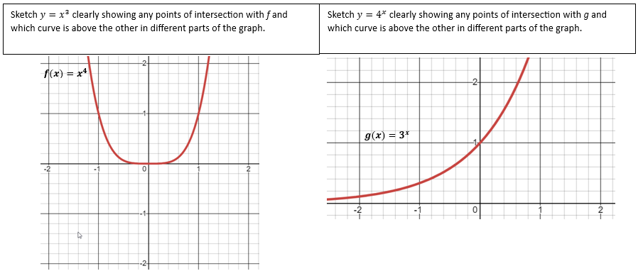
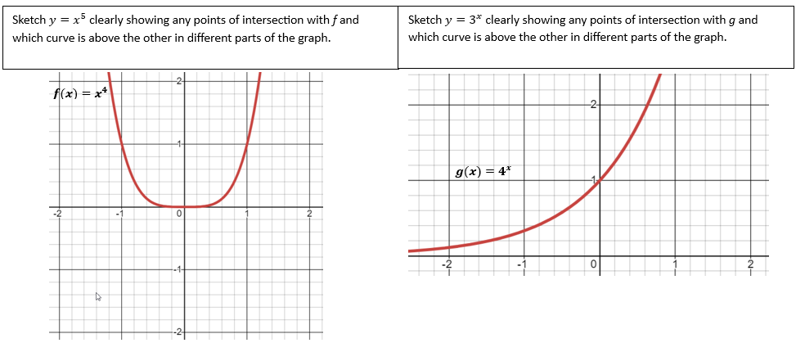
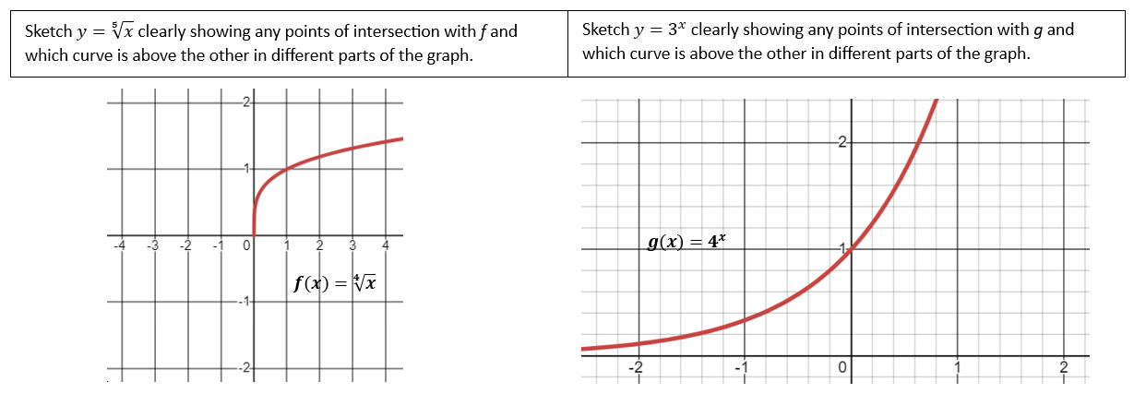

1 - 1 – Function Families – Solutions

1. [P] Match each curve with its equation.
A
B
C
D
E
$y=\sqrt[5]{x}$ __A__
$y=2^{x}$ __D__
$y=5^{x}$ __C__
$y=x^{3}$ __E__
$y=x^{11}$ _B___

2. [P/C] Sketch a graph of $y={\sqrt{2}}^{x}$. Label two sets of coordinate points you know on the graph.
Don’t get thrown off by the $\sqrt{2}$ here. The form is an exponential. Look at it like: $y={\left(number\right)}^{x}$.
So you know the overall shape looks like any exponential. You know (0, 1) is a point on all exponential functions. You can plug in any x-value to find a corresponding y value for the other point.

$$(0, 1)$$
$$\left(1,\sqrt{2}\right)$$

3. [P/C] For each pair of functions, write all points where they overlap. Which function has larger y-values to the right of the overlapping point? to the left?
a. $y=\sqrt[3]{x}$ $y=\sqrt[4]{x}$ (0,0) and (1, 1). $\sqrt[4]{x}$ has larger y-values when 0 < x < 1. Otherwise $\sqrt[3]{x}$ does.
b. $y=2^{x}$ $y={0.5}^{x}$ (0, 1). $2^{x}$ has larger y-values when x > 0.
c. $y=\frac{1}{x}$ $y=\frac{1}{x^{2}}$ (1, 1) is the only point in common. $y=\frac{1}{x^{2}}$ has larger y-values when 0 < x < 1. You can verify this by testing a point. If $x=\frac{1}{2}$: $y=\frac{1}{\left(\frac{1}{2}\right)}=2$ whereas $y=\frac{1}{{\left(\frac{1}{2}\right)}^{2}}=4$.

4. [P/C] The two questions below are phrased algebraically. Think about what they’re asking about the graphs of the equations. You can answer both questions just by translating the question to one about a graph and then looking at the graph in your mind.

a). If $f\left(x\right)={11}^{x}$ and $g\left(x\right)={\sqrt{2}}^{x}$, for what values of k is $f\left(k\right)=g(k)$?

When it asks: “for what values of k is $f\left(k\right)=g(k)$” it’s asking for two x values that have the same output (or y-value). If you try and set up an equation ${11}^{k}={\sqrt{2}}^{ k}$ it may or may not occur to you that $k=0$ is the only solution. If you imagine it as a question about the graphs, then it may be easier to realize that the two graphs cross only at $(0, 1)$. So $k=0$ is the only solution.

b). Say that $f\left(x\right)=5^{x}$ and $g\left(x\right)=b^{x}$ for some number b. If $f\left(-3\right)>g(-3)$ what do you know about b?

When it says $f\left(-3\right)>g(-3)$, this is saying that at $x=-3$, the graph of f is above the graph of g (since it has a larger y-value).
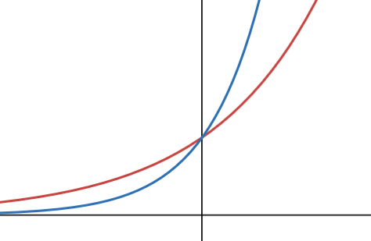
$$y=5^{x}$$
If $5^{x}$ is above $b^{x}$ when $x=-3$, we’re talking about this kind of thing. Notice that if $5^{x}$ is on top when $x=-3$, then $b^{x}$ is on top when $x>0$.

What values of b could work here? You could just test some values if you’re unsure: test $b=2$ and $b=10$.

You can see that $b$ must be larger than 5.

5. [P/C] Without a calculator, which is larger: $\sqrt[5]{\frac{1}{4}}$ or $\sqrt[7]{\frac{1}{4}}$ ?
Think about the graphs of $y=\sqrt[5]{x}$ and $y=\sqrt[7]{x}$ at x = ¼. $\sqrt[5]{x}$ is below $\sqrt[7]{x}$ when 0 < x < 1. Therefore $\sqrt[7]{\frac{1}{4}}$ must be larger.

6. [P/C] Which of the following have a domain of all real numbers? Which of them have a range of all real numbers?

You should answer these questions by looking at the graph in your mind.

$y=x^{100}$ D: all reals, R: $y≥0$ $y=x^{51}$ D: all reals, R: all reals $y=\sqrt[3]{x}$ D: all reals, R: all reals
$y=\sqrt[14]{x}$ D: $x≥0$ $y=\frac{1}{x}$ $D:x≠0$, $R:y≠0$ $y={11}^{x}$ D: all reals, R: $y>0$
$y={18}^{x}$ D: all reals, R: $y>0$

7. [C] Which families of functions have a horizontal asymptote? A vertical asmptote?
The idea here is for you to easily be able to “browse” pictures of the functions in your head. Later when you want to use these functions, you’ll need to be able think: “I want a function that has an asymptote” and know what options you have.
Horizontal: Exponential functions $y=b^{x}$ have a horizontal asmptote, as does $y=\frac{1}{x}$.
Vertical: $y=\frac{1}{x}$ also has a vertical asmptote, as do the family of log functions $y=\log_{b}{(x)}$
8. [P/C]




